**Create Organisation Lookup**

1) Go to Design Console then Lookup Def then search with **Lookup.LDAP.Organisation**

2) Give the Code and Decode with **ou=people.dc=rackspace,dc=com**

3) To Add the DN lookup to the design console, we need to run the scheduler job of

**LDAP Connector OU Lookup Reconciliation**

Set ITResource = Enterprise Directory-oud

Then apply and run the job after success with job

Go to design console and Adminstration then Lookup Defination search with

**Lookup.LDAP.Organisation.**

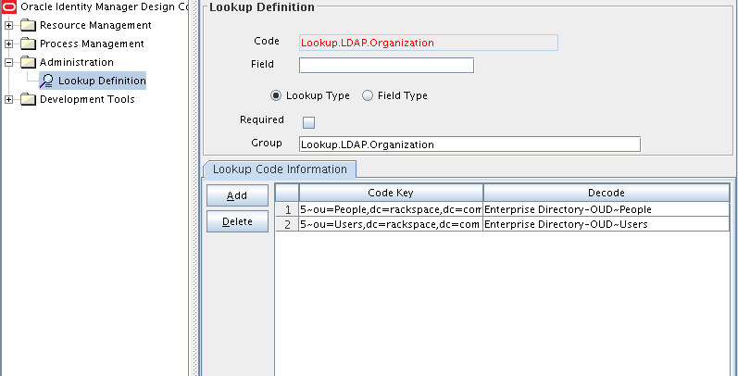

**To add the Groups lookups**

1) Go to Design Console then Lookup Def then search with **Lookup.LDAP.Group**

2) To Add the DN lookup to the designconsole, we need to run the scheduler job of

**LDAP Connector Group Lookup Reconciliation**

Set ITResource = Enterprise Directory-oud

Then apply and run the job after success with job

Go to design console and Adminstration then Lookup Defination search with

**Lookup.LDAP.Group.**

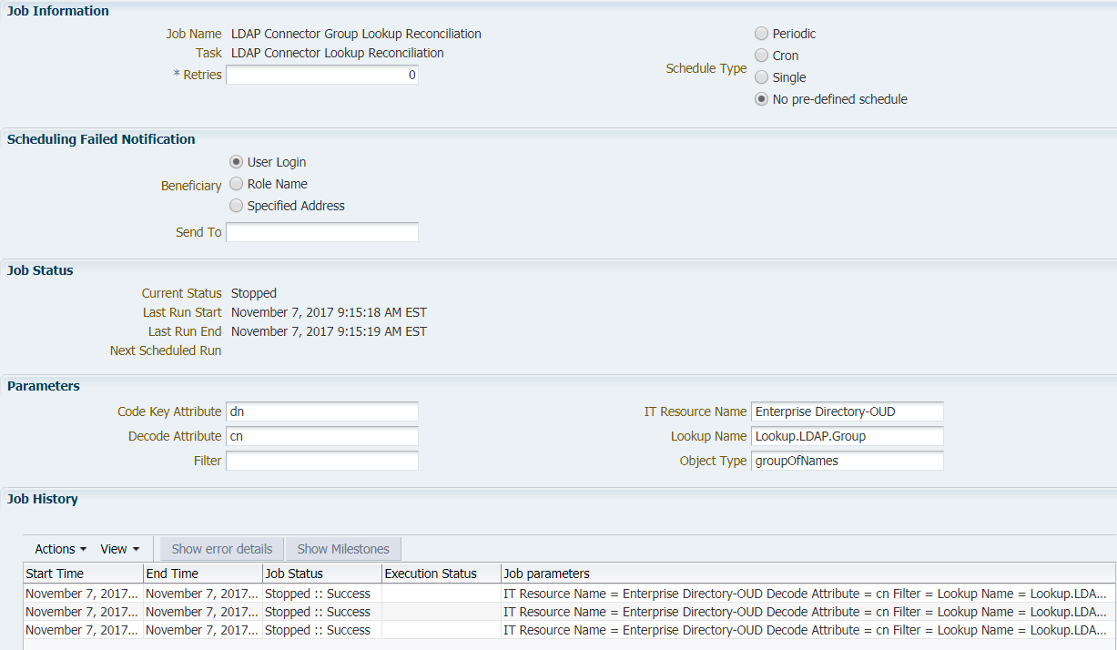

After Running the job Lookup codes are

